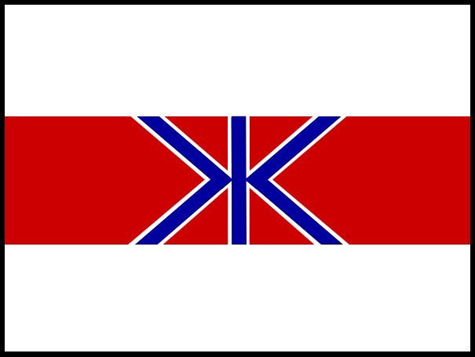
FISHERIES AGENCY
MINISTRY OF AGRICULTURE, FORESTRY AND FISHERIES, GOVERNMENT OF JAPAN

2-1, 1-Chome, Kasumigaseki, Chiyoda-ku, Tokyo 100, Japan TEL:03-3502-8111 EXT:

OPENING STATEMENT OF JAPAN
58th ANNUAL MEETING INTERNATIONAL WHALING COMMISSION

The Government of Japan expresses its appreciation to the Government of St. Kitts and Nevis for hosting the 58th Annual Meeting of the IWC and for the hospitality we have received. We are pleased to be here on your beautiful island of St. Kitts.

This 58th Annual Meeting marks a serious turning point for the IWC. The IWC has been dysfunctional because of fundamental differences in the position of its members. It has become a mere stage for emotional and political conflicts at the sacrifice of the original mission of the organization: conservation and sustainable use of whale resources.

Japan, together with other members supporting the sustainable use of whale resources, has great concerns about this situation and is to express its commitment to normalizing and saving the IWC as a resource management organization. We are convinced that the IWC can only be saved from its current crisis by respecting and interpreting in good faith the International Convention for the Regulation of Whaling (ICRW). This means protecting endangered and depleted species while allowing the sustainable utilization of abundant species under a controlled, transparent and science-based management regime.

Since the adoption of the moratorium in 1982, the IWC has failed to meet its main objective as mandated by the ICRW; that is, “to provide for the proper conservation of whale stocks and thus make possible the orderly development of the whaling industry”. Now, after 14 years of discussions and negotiations to complete a Revised Management Scheme (RMS), this failure has been confirmed by the decision to postpone further discussions on the completion of RMS. We sincerely regret this decision.

The IWC Scientific Committee’s reports have clearly shown that many species of whales have recovered – others are recovering. It also shows that science allows sustainable harvest of abundant species of whales without depleting their stocks. Modern enforcement and monitoring measures can prevent the repetition of the past over-harvesting.

Use of cetaceans, like other fishery resources, contributes to sustainable coastal communities, sustainable livelihoods, food security and poverty reduction. Whales should be treated as any other marine living resources available for harvesting subject to conservation and science-based management. Scientifically and legally, there is no reason to treat cetaceans differently.

At this IWC meeting in St. Kitts, Japan will initiate a consultation process to bring the IWC back on the right track. We encourage those members that support the ICRW and the principle of sustainable use to join this normalization process. Failure of this initiative would mean that the IWC will lose its raison d’etre as an intergovernmental organization for resource management.

ENDS

For more information, contact Japan Delegation media adviser
Glenn Inwood +1 869 764 4301

