IWC 60
BRIEFING NOTE
Briefing Note: Joji Morishita, Delegation of Japan

Introduction

Japan’s objective is to resume sustainable whaling for abundant species under international control including science-based harvest quota and effective enforcement measures. At the same time we are committed to conservation and the protection of endangered species. This is the purpose of the International Convention for the Regulation of Whaling (ICRW).
BRIEFING NOTE
Decisions in the IWC should respect science, international law and cultural diversity. Consistent application of science based policy and rule making together with the principle of sustainable use is the paradigm for the management of living resources accepted worldwide. Emotionalism is unhelpful in resolving difficult international negotiations and has led to the current dysfunctional nature of the IWC. Japan has been working hard to normalize the functioning of the IWC. That is, to make the IWC an example of the international community working under a set of sensible rules and sharing common resources.

Japan’s policy on whaling and its position in the IWC have been subject to criticism. Much of this is based on misunderstanding and misinformation. The following are responses to the most commonly raised/misunderstood points:

- Whales are endangered and should not be hunted. Past commercial whaling resulted in over-harvesting and proved uncontrollable.

Response: Many species and stocks of whales are abundant, increasing and recovering from past over-harvesting. The IWC’s website (http://www.iwcoffice.org/), which provides population figures agreed by its Scientific Committee confirms this (see attached table). In 1990, the Scientific Committee agreed that there were 760,000 minke whales in the Antarctic. This estimate is currently being reconsidered. Even if a new estimate shows a lower abundance there is still a large number of minke whales which can be utilized sustainably. The Scientific Committee also agrees that humpback whales are increasing at about 10% per year. These estimates of abundance clearly show that whaling under strict quotas would be sustainable.

Past commercial whaling did result in over-harvesting. However, much has been learnt about the science of whales and the science of resource management since that time. The IWC’s Scientific Committee has developed a risk-averse method of calculating catch quotas and this was adopted by the IWC in 1994. This method called the “revised management procedure” (RMP) together with a monitoring and inspection scheme would provide a regime to ensure that commercial whaling would be sustainable and that regulations are followed. Further, past commercial whaling was for a worldwide oil market when whales were regarded as industrial material resulting in over-harvesting to support industrial developments. However, whaling now is for food with limited markets and therefore much less demand. Over-harvesting will not be repeated.

- Japan is undermining the conservation objectives of the IWC.

Response: The purpose of the International Convention for the Regulation of Whaling as stated in the Convention (ICRW) is “to provide for the proper conservation of whale stocks and thus make possible the orderly development of the whaling industry”. The ICRW requires that regulations adopted by the IWC be based on scientific findings to ensure that whaling is sustainable. Consistent with the objective of the IWC, Japan supports sustainable whaling under international control.

Unfortunately, many members of the IWC ignore these facts. These members of the IWC are opposed to any whaling irrespective of the science and status of the stocks. Their “conservation” is total prohibition of whaling and their position cannot be justified by science and international law, including the ICRW. If they cannot agree with the purpose of the ICRW, which is sustainable utilization of whales through the proper conservation of whale stocks, they should withdraw their membership and leave the IWC.

- Japan’s whaling is contrary to world opinion.

Response: In 1992, the UN Conference on Environment and Development (UNCED) held in Rio de Janeiro, reaffirmed the provisions of the Convention on the Law of the Sea, an agreement that permits whaling on the high seas, and explicitly rejected the efforts of anti-whaling nations to exclude whales from the list of resources open to sustainable use and development. Also, at both the 1997 and 2000 Conferences of the Parties to the Convention on International Trade in Endangered Species (CITES), more than half the countries present supported the controlled use of minke whales.

Anti-whaling is therefore not “world opinion”. In fact, people in many countries around the world use whales and small cetaceans (dolphins and porpoises) for food. Even among populations that do not use whales for food there is widespread support for the principle of sustainable use of resources, including whales. China, Russia, Norway, Iceland and many developing countries support sustainable utilization of whales. Anti-whaling is a predominantly western phenomenon in developed countries amplified by the western media.

- There is no need to hunt whales for food. Whale meat is only a high priced menu item in expensive restaurants.

Response: The Japanese have been eating whale meat and utilizing whalebones, blubber and oil for more than 9,000 years (Hiraguchi, 2003). However, since the 1960’s, the supply of whale meat gradually declined because of restrictions on whaling and consumption has reduced accordingly. We didn’t make whale meat an expensive luxury by our own decision. The restrictions which include abundant species transformed the inexpensive and nutritional daily food into a luxury.

Japanese dietary habits, which are deeply rooted in history, show that whale meat has been a protein source as ordinary, everyday food but it also has been treated as a special food with regional and social significance. The total protection of all whales irrespective of their stock status as promoted by some members of the IWC and some environmental and animal welfare organizations is exclusive of other views and ways of living. It is contradictory to Japanese cultural values where whale meat is still eaten and where whales are still revered through religious ceremonies and festivals.

A more inclusive approach is supported by the following Declaration:
In December 1995, 95 States agreed to a Declaration and Plan of Action on the occasion of the International Conference on the Sustainable Contribution of Fisheries to Food Security. Among other things, the Declaration specifically “Call(s) for an increase in the respect and understanding of social, economic and cultural differences among States and regions in the use of living resources, especially cultural diversity in dietary habits, consistent with management objectives”. Sustainable whaling and the consumption of whale meat in Japan are fully supported by this Declaration.

- Japan is buying votes at the IWC with its foreign aid.

Response: This accusation is false. Japan is one of the world’s largest donors, providing aid to over 150 countries. This aid is not linked to the policies of recipient nations on specific issues. In fact, Japanese aid is provided to a number of countries including Argentina, Brazil, India and Mexico that are opposed to whaling.

Accusations of vote buying are part of a campaign of threats and intimidation by extremist NGOs against Caribbean nations that have supported the principle of sustainable use of all marine resources including whales.

No one should be surprised that nations dependant on the resources of the sea would vote in a similar manner to Japan in the IWC. Contrary to the claims of anti-whaling interests, Caribbean countries are also whaling nations. They have voted in support of sustainable use of whales because they use cetacean resources as food themselves. Accusations that their votes have been bought are an insult to the sovereignty of these nations to vote as they wish within the IWC.

- Japan is using a “loophole” in the Convention to conduct it research whaling. Japan’s whale research programs are “commercial whaling in disguise”.

Response: Research whaling is a fundamental right of every member of the IWC according to Article VIII of the ICRW. It is not a “loophole” in the Convention and Japan’s whale research programs are therefore perfectly legal. Further, Article VIII. 2 requires that research by-products (meat) be processed and sold. This is a legally binding obligation, based on common sense, not to waste the meat.

More than 100 data items and samples are taken from each whale including ear plugs for age determination studies, reproductive organs for examination of maturation, reproductive cycles and reproductive rates, stomachs for analysis of food consumption and blubber thickness as a measure of condition. These data and the analyses of the data provide us with valuable scientific information on whales and the ecosystem of which they are a part.

Japan submits the results from its research to the IWC Scientific Committee for review every year, again, contrary to the claims of anti-whaling interests. Both the quality and quantity of data from Japan’s research programs have been commended by the Scientific Committee. The IWC’s Scientific Committee has noted that the programs have provided considerable data that could be directly relevant for management and that the results of these programs have the potential to improve the management of minke whales. The Scientific Committee has also noted that non-lethal means to obtain some of this information are unlikely to be successful particularly in the Antarctic.

- The IWC has passed numerous resolutions urging Japan to stop its whale research programs but Japan has ignored these.

Response: Resolutions are adopted by the IWC by a simple majority vote. Unlike the IWC’s “regulations”, which require a ¾ majority, “resolutions” are not binding. Resolutions adopted by the IWC against Japan’s whale research programs are political statements that have nothing to do with science. Furthermore, they are often inconsistent with Article VIII of the ICRW. Such resolutions have usually been passed by the IWC by only a small number of votes, meaning that generally half of the IWC has opposed such resolutions. On the other hand, the IWC’s Scientific Committee has highly evaluated Japan’s research programs.

- It is not necessary to kill whales to study them.

Response: Japan’s research programs involve both lethal and non-lethal research techniques, such as sighting surveys and biopsy sampling. While certain information can be obtained through non-lethal means, other information requires sampling of internal organs, such as ovaries, ear plugs and stomachs.

For example, while the population age structure and reproductive rates of land mammals can be determined by observation over a period of time, such is not the case for whales because they spend most of their time underwater. In this case, we need ear plugs for age determination and ovaries to establish reproductive rates. Similarly, to study the interactions of whales and other parts of the marine ecosystem we need to know what, how much, where and when they are eating. This is done by examining stomach contents. DNA analysis only reveals what they have eaten, at most not when, where and how much. Another example is that for pollution studies, tissue samples from various internal organs are required.

Lethal studies are a standard research approach for other species and there is no scientific reason to exempt whales from this standard approach.

- Japan’s research is not providing useful or necessary information.

Response: This is incorrect. See comments from the IWC’s Scientific Committee in footnote 4 above.

- It is not possible to kill whales humanely.

Response: In fact, a large proportion of the whales taken are killed instantly by an explosive harpoon and for those cases when they are not, a secondary killing method (a second harpoon or high caliber rifle) ensures that the time to death is as rapid as possible. These two methods were introduced to ensure the most efficient and humane killing. The IWC has said that the explosive harpoon is the most effective method for killing whales and significant improvements to the humaneness of the hunt have been made.

It is not appropriate to compare the data of whaling with that of a slaughterhouse where killing is conducted in a controlled factory-like manner. Comparison with wildlife hunting such as deer and kangaroo is more appropriate. Instantaneous death and time to death of less than two minutes for whales is far better than the killing of most other wildlife.

- Japan is whaling in the “IWC Antarctic Sanctuary” and in waters claimed by Australia and designated as a sanctuary under Australian domestic law.

Response: The IWC sanctuary in the Antarctic applies to commercial whaling only. It does not apply to research whaling conducted under Article VIII of the ICRW. In regards to Australia’s designated sanctuary, many countries including the U.S. and Japan do not recognize Australia’s Antarctic claim. The Antarctic Treaty, to which Australia is a member, freezes all Antarctic claims. From the perspective of the international community therefore, Australia’s claim and its sanctuary in Antarctic waters, which it has declared under its domestic legislation, has no legal standing in international law and therefore no effect.

- There is no need to expand Japan’s whale research catch in the Antarctic by increasing the number and taking additional species such as fin and humpback whales.

Response: The expansion of the research is based on genuine scientific needs described in detail in Japan’s research plan submitted to the IWC. The previous 18 years of research have shown evidence that the Antarctic ecosystem is changing so it is necessary to continue monitoring and sampling in order to understand the dynamics of whale species interactions. This will contribute to the conservation, management and sustainable utilization of whales in the Antarctic Ocean.

The research area has been expanded and fin and humpback whales have been added because they are showing rapid increases in the area and have a large role in the ecosystem. By collecting data on these species we will be able to test hypotheses concerning changes in the Antarctic ecosystem, as well as develop an ecosystem-based management scheme for whale resources.

Sample sizes have been calculated as the minimum number required to obtain statistically significant data and will not have any detrimental effect on the stocks. This is similar to doing public opinion polls – you don’t ask everyone in the entire population for their view but you need to ask more than one person. The number you need to ask increases when the size of the population is large and the degree of accuracy required is high.

- Taking of humpback whales for research will have a negative impact on whale watching operations in Australia and New Zealand. Whales are worth more alive than dead.

Response: The IWC Scientific Committee and even Australian scientists agree that humpback whales are increasing at approximately 10% per year. The small catches of humpback whales will have no impact on whale watching opportunities. Claims to the contrary are an emotional response without scientific foundation.

There are enough whales for those who want to watch them and for those who want to eat them. It is unfortunate that anti-whaling interests promote a perception of conflict between whale watching and whale eating. The situation is not different from a farm tour with a BBQ lunch. Whaling and whale watching are not mutually exclusive. In Japan, Norway and Iceland, both whale watching and whale eating are accepted and these activities share the same goal of keeping healthy and abundant whale populations for their perpetual existence.

A detailed study of the estimated value of whale watching has shown that the commonly quoted values of whale watching are grossly inflated estimates because they were derived using faulty methodology.

- Japan must respond to the political pressure from its major trading partners and otherwise friendly countries.

Response: Japan has received political representations from a number of countries urging a change in its whaling policy. The difference of views on the whaling issue has not affected and should not affect the overall good relationship Japan has with these countries. However, the fact that we have a difference of view does not mean that Japan should change its position. Japan is not insisting that Australians or Americans eat whale meat, but these countries do not have the right to impose their ethical or moral values on Japanese as long as whales are sustainably utilized. Japan’s position in the IWC is fully consistent with international law and science. Mutual respect for differences, not political coercion, is the solution to this difficult issue.

- Japan has refused to accept an open and transparent monitoring scheme as part of the RMS.

Response: This criticism is blatantly false. Japan is willing to accept a practical, effective and cost efficient monitoring and inspection scheme including national inspectors and international observers to verify catches, a conservative harvesting quota, and a fair sharing of the costs. Japan’s commitment to secure the implementation of a reasonable RMS is demonstrated by the substantial compromises and proposals we have made.

On the other hand however, IWC members with extreme anti-whaling positions have failed to make any substantive compromises and have delayed negotiations for over 10 years by insisting on an always-increasing list of unnecessary, duplicative and excessively costly measures for controlling whaling operations. It is also the anti-whaling members of IWC that rejected the Chair’s initiative to complete an RMS at IWC 56 meeting. This is not surprising because extreme anti-whaling members are opposed to whaling under any circumstances and the completion of an RMS, which means a resumption of well-managed whaling, is contrary to their position.

We are also particularly disturbed that anti-whaling members of the IWC have also added another condition to the completion of any RMS namely, that the right of IWC members to conduct research whaling under Article VIII of the ICRW be abolished. This demand is nothing but a further attempt to prevent the completion of an RMS. Japan and other members of the IWC who support the principle of sustainable utilization cannot accept any such condition for legal and scientific reasons. Further, it is simply not logical to have to give up a fundamental right provided by the Convention (the right of all Parties to issue permits for the conduct of research whaling) in order to resume what is the primary purpose of the same Convention – sustainable commercial whaling.

- Japan and some other members are talking about “Normalizing” the IWC. What does that mean?

At its meeting in Cambridge from February 28 to March 2, 2006, the IWC’s RMS Working Group agreed to postpone further discussions on completing an RMS. This decision was the culmination of 14 years of discussion and negotiations and an admission that the IWC has failed to carry out its functions (“… to provide for the proper conservation of whale stocks and thus make possible the orderly development of the whaling industry.”) mandated by the International Convention for the Regulation of Whaling.

It must be remembered that the 1946 International Convention for the Regulation of Whaling is about properly managing the whaling industry, that is, regulating catch quotas at levels so that whale stocks will not be threatened. The Convention is not about protecting all whales irrespective of their abundance.

Therefore Japan, together with other members supporting the sustainable use of whale resources, have expressed their commitment to normalizing the IWC. We are convinced that the IWC can only be saved from its current crisis by respect for and good faith interpretation of the ICRW. This means protecting endangered and depleted species while allowing the sustainable utilization of abundant species under a controlled, transparent and science-based management regime.

Further details concerning the need for and process to normalize the IWC are contained in Japan’s opening statement to the 58th Annual Meeting and a document submitted to the IWC by Japan and other members who support the sustainable use of whale resources.

For more information contact
Japan Delegation Media Office in Chile:
Glenn Inwood +56-99-787-1758

日本から呼び出す場合：国際識別番号+56
9234-5687（鈴木 亮太郎 外務省経済局漁業室長）
9234-5741（桐生 大輔 外務省経済局漁業室）

日本から呼び出す場合：国際識別番号+56

En español por favor llame al 808-990-1894
Download this document at:
www.icrwhale.org/eng/60BriefingNote.pdf
www.icrwhale.org/eng/60BriefingNote.doc
Whale Population EstimatesThe International Whaling Commission's most recent information on estimated abundance
http://www.iwcoffice.org/conservation/estimate.htm

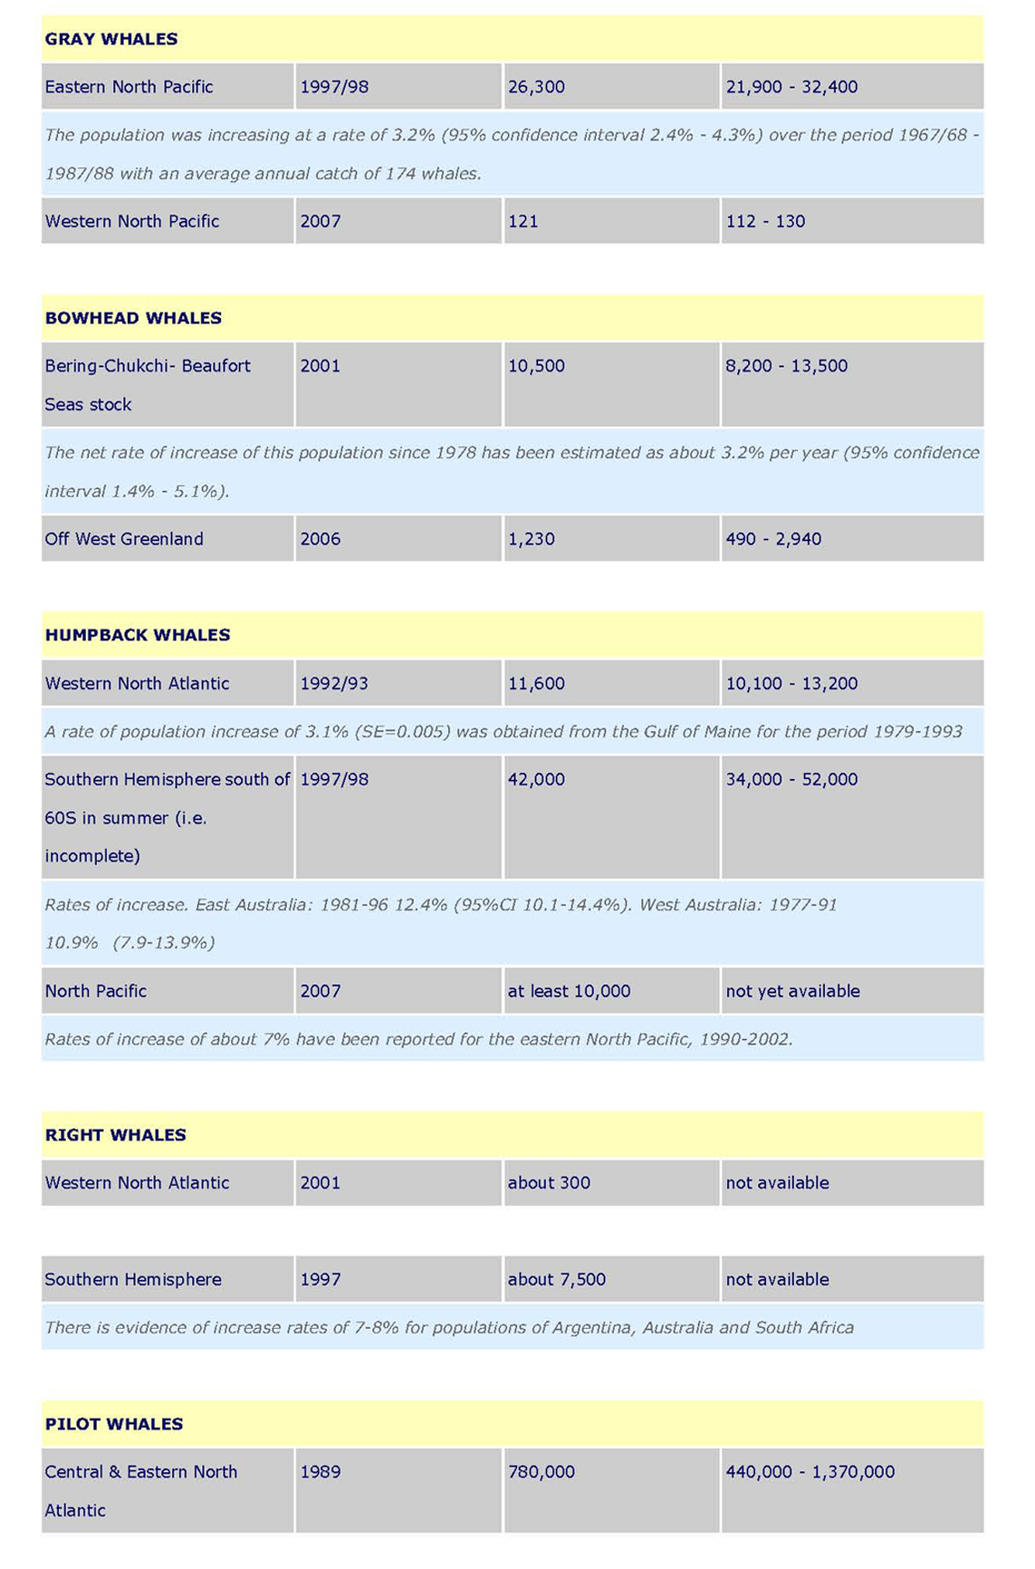

The purpose of the International Convention for the Regulation of Whaling as defined in the Convention is “to provide for the proper conservation of whale stocks and thus make possible the orderly development of the whaling industry”.
? These principles are included for example in the United Nations Convention on the Law of the Sea, Dec. 10, 1982, Agenda 21, June 14, 1992; the FAO Kyoto Declaration and Plan of Action on the Sustainable Contribution of Fisheries to Food Security and the FAO Code of Conduct for Responsible Fisheries, Oct. 31, 1995, and the Convention on Biological Diversity.
RMP is a risk-averse method of calculating quotas for abundant stocks of baleen whales developed by the IWC Scientific Committee and adopted by the Commission in 1994 by consensus. The RMP would allow harvesting only for abundant stocks, has been tested with thousands of simulation trials over a period of 100 years, has built in safety factors to take account of uncertainty (including the impacts of possible environmental changes) and is a feedback system requiring new abundance estimates every 5 years. The RMP is the most conservative and robust system ever developed for the management of any wildlife species.
See for example: IWC document 49/4 Report of the Scientific Committee, 1997, which is the source of the following quotes: “The information produced by JARPA (Japan’s Antarctic Research Program) has set the stage for answering many questions about long term population changes regarding minke whales in Antarctic Areas IV and V.” “…JARPA has already made a major contribution to understanding of certain biological parameters.” “The Committee noted that JARPA is at the half-way point and has provided substantial improvement in the understanding of stock structure.” “…there was general agreement that the stock structure data were of value to management.” “…the meeting noted that there were non-lethal methods available…but that logistics and the abundance of minke whales in the relevant Area probably precluded their successful application.” See also, IWC document: Report of the Workshop to Review the Japanese Whale Research Programme under Special Permit for North Pacific Minke Whales (JARPN), Tokyo, 7-10 February 2000 from which the following quotes are taken: “the Workshop noted that … information obtained during JARPN had been and will continue to be used in the refinement of Implementation Simulation Trials for the North Pacific Minke whales, and consequently were relevant to their management.”
Article VIII of the ICRW begins with the words “Notwithstanding anything contained in this Convention….”
A Bioeconomic and Socio-economic Analysis of Whale-Watching, with Attention given to Associated Direct and Indirect Costs. By Dr Brendan J. Moyle (Massey University, New Zealand), and Dr Mike Evans (University of Alberta, Canada). Submitted for publication.
RMS includes the RMP (see footnote 3), an inspection and observation scheme, guidelines for surveys used to estimate abundance and specification of minimum data requirements.

