Whales as food and Japanese culture
MEDIA BRIEF

MEDIA BRIEF

The Japanese have been eating whale meat and utilizing whalebones, blubber and oil for more than two thousand years. Active hunting for large cetaceans has a history of more than 400 years. Offshore whaling activities began after the Meiji Restoration in 1868, however some whaling remained within the traditional areas where it still plays an important role as the basis of solidarity in the community. In the years immediately following World War II (1947–1949) the consumption of whale meat was about 45% of the total meat consumption in Japan after which it remained at about 30%. However, since the 1960’s the supply of whale meat has gradually declined and accordingly consumption has been reduced. The significance of whale meat in Japanese dietary habits however, is still very important at present.

Japanese dietary habits which have been deeply rooted in history show that whale meat has been an important protein source as ordinary everyday food but it also has been treated as a special food with regional and social significance. In the areas where whaling has been conducted traditionally, these dietary habits have become an integral part of the community such that all local ceremonies or festivities include the serving of some whale meat dishes.
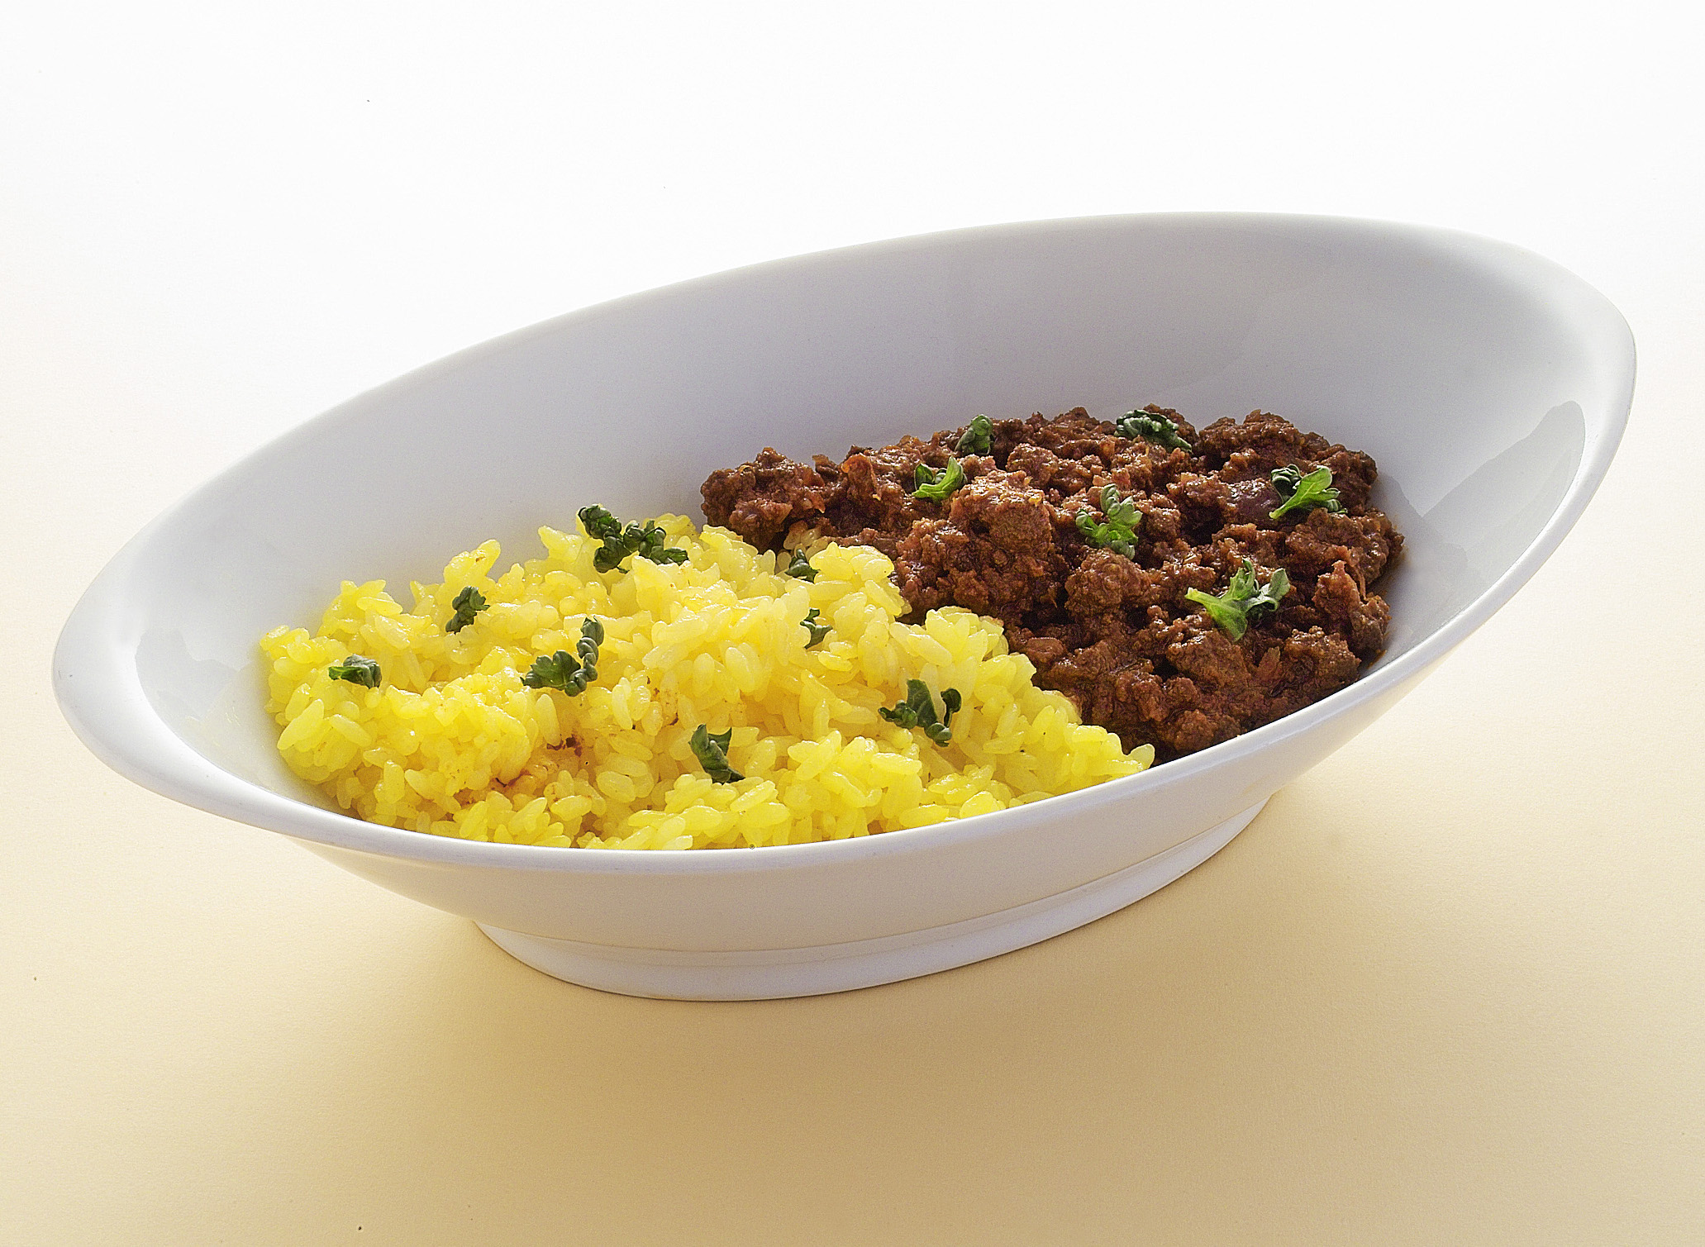
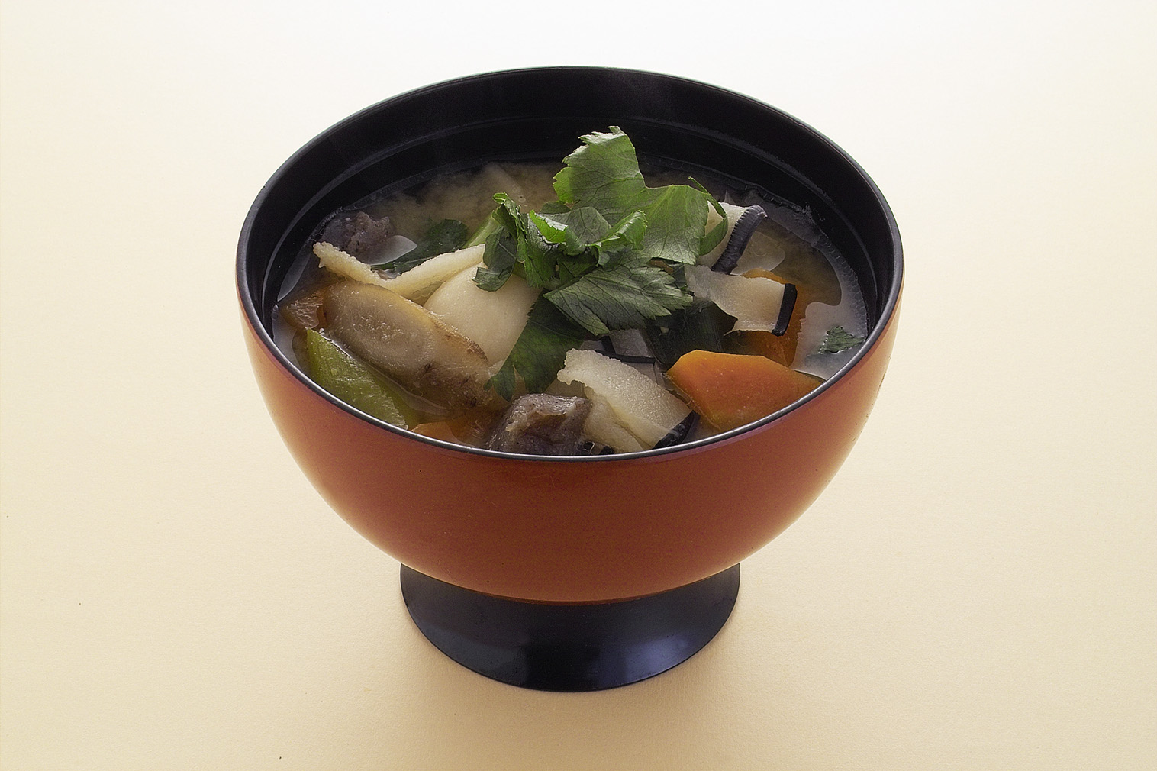

The whale to the Japanese in ancient times was a kind of fish that was thought to be brave and great. Today, along with all other marine resources, whales continue to be viewed as a source of food to be used sustainably. The total protection of all whales irrespective of their stock status as promoted by some members of the IWC and some environmental and animal welfare organizations is contradictory to Japanese cultural values where whales are viewed as a food resource and where whales are still revered through religious ceremonies and festivals. This is particularly so for those communities where the local peoples lives have depended on whaling activities.

Download this document at:
www.icrwhale.org/eng/59Culture.pdf
www.icrwhale.org/eng/59Culture.doc

